**PRC CONNECTIONS**

**PULTNEYVILLE REFORMED CHURCH**

**7784 Hamilton Street, P.O. Box 94, Pultneyville, NY 14538**

**Church Office — 315-589-2703**

**Email — prc@pultneyville.org Website — www.pultneyville.org**





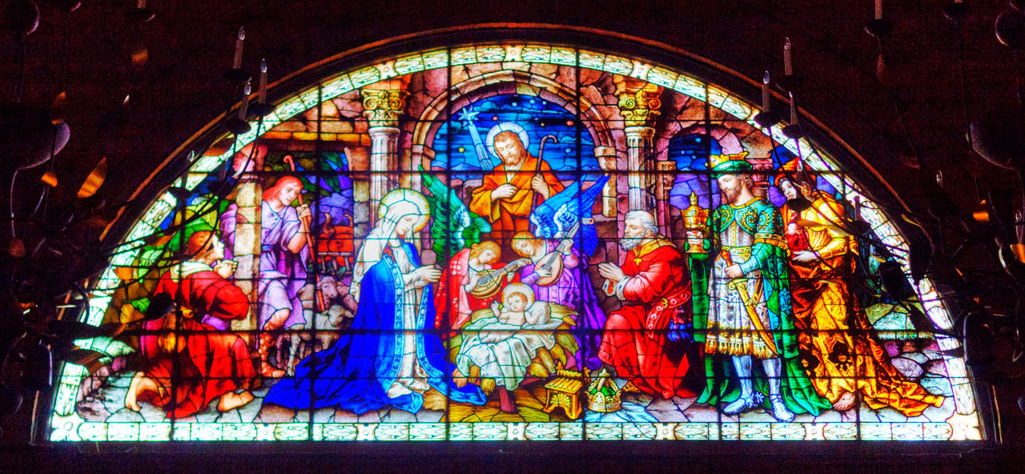

**December 2022**

**VOLUME XL**

**ISSUE 12**



***The Dream of God***

***December 2022***

People dream. We dream about the things we hope for in our lives and in the lives of our loved ones. We dream big and we dream small. We also see our dreams fade before us unfulfilled, leaving hurts and holes in our souls. Sometimes our dreams are realized and for a moment everything seems right in our private world.

There are some people who make a living making other’s dreams come true. Think of all the matchmaking websites out there. And then there are people who are just invested in helping others achieve their dreams for the sheer joy of watching others take off and soar. Those people become personally invested in others giving in order to see something beautiful flourish. They dream the dream of the other and make it their own. This is a wonderful ministry, and it puts us in touch with another dream—God’s dream.

We probably think rarely, if at all, about God having a dream. I believe that God has a dream for creation and for humanity. I think this dream is found in the words reconciliation and redemption. God’s dream is that all of creation would be reconciled to him. God acts upon that dream in the incarnation of Jesus Christ. In this event God acts to fulfill his dream. God enters into and interrupts the dreams and schemes of humanity to pronounce the priority of the Divine plan. That is the center of the Christmas message.

But the dream of God goes not only to a restored fellowship with humanity. It reaches into every corner of human endeavor. This is the act of redemption. In the coming month you will hear a good deal from the prophet Isaiah. What unfolds in the prophet Isaiah is God’s dream which also taps into our deepest and most profound dreams.

Let’s look at some snippets of God’s dream from Isaiah 58: “loose the bonds of injustice, let the oppressed go free, bring the homeless into your house, clothe the naked, keep from speaking evil and finger pointing, offer food to the hungry, satisfy the needs of the afflicted, refrain from trampling the sabbath and pursuing your own interests on God’s holy day.” This is only a part of God’s dream. It is an if…then dream. The first part is *if.* The second part is *then.* Let’s take a look at this part of God’s dream: “your light will shine in darkness, the Lord will satisfy your needs in parched places, your ancient ruins will be rebuilt, you will ride upon the heights of the earth.” God’s dream is a dream of redemption for all of humanity from those in the most vulnerable circumstances to the highest in rank. When we participate in God’s dream we dream for the betterment of others, and we find the promise of God that God will honor that in the most marvelous ways.

Reconciliation and Redemption. These are God’s dreams. These are God’s gifts to us each and every day of the year. It is not just a dream that happens on Christmas, it is the dream that is to fill the life of each and every Christian always. Let the seed of God’s dream take root this Christmas but nurture it throughout the year, and see the Lord fulfill for you the promise of his dream.

A Blessed Christmas to You,

Pastor Eric

Dear Friends and Family of Pultneyville Reformed Church,

I want to let you know of a couple of important meetings that are coming up. The first is the A**nnual Congregational Meeting.** We will talk a little about the state of the Church (and church) as well as taking a vote on whether or not to approve the 2023 budget. It is an important meeting and I do urge everyone who can to attend. This meeting is scheduled for **Sunday, December 4th** following the service of worship. We will meet in the Fellowship Hall. We are facing some financial challenges presently and so we need everyone to be aware of where we stand with respect to our budget. We are also in the midst of significant staff changes as Karen Manahan retires at the end of the year after 31 years of faithful service. We are also saying goodbye to our sextons Fred and Marlene Walvoord after 27 years of faithful service. These are really watershed changes, so we all need to be aware of adjustments and transition pains.

Secondly, not only do we have financial and transitional challenges, we also have significant existential challenges in the Church universal and in particular (here at PRC). Almost all churches, but especially those on the East coast (ecclesiastical trends tend to begin here and then spread westerly) are in decline and have been for some time. Pultneyville Reformed is no exception. The consistory is aware that a major denominational restructuring process is beginning to address these changes. We thought it important that we too should sit together as a congregation to discuss these challenges and to talk about ways we might address them. In order to begin this conversation, we will have a **February Forum** on **Sunday, February 19th at 11:15** in the Fellowship Hall. Lunch will be provided. I believe Pultneyville Reformed Church can flourish, but we need everyone on deck so please make plans to attend this important presentation and conversation.

May the Peace of Christ be with You,

Pastor Eric



**Congregational Meeting**

**Sunday, December 4th**

**Following Worship**





We invite you to attend our candlelight Christmas Eve Worship Service on Saturday,

December 24that 9:00 p.m. in our sanctuary.

**Angel Tree** 

Our Angel Tree will be set up in Trinity Hall by Sunday, November 27th and will be filled with angels bearing the gender, age and gift ideas for a particular person or family. It is also filled with food items for the families. We will be sponsoring four families this year. Please consider taking an angel or food item from the tree and shopping for the person/family listed on it. There is a box under the tree for monetary donations which will be used to buy gifts and food that have not been spoken for. All of the gifts, wrapped and with the angels attached to the outside of the gift need to be returned under the tree by noon on Sunday, December 18th. Food items should be left on the table in Fellowship Hall by the same date. Consistory members will deliver the food and gifts to the families. Thank you for your generosity!

**Williamson Fellowship of Churches**

**Vespers Service**

**Sunday,**

**December 11th 7:00 p.m.**

**Williamson United Methodist Church**



**PRC Christmas Caroling Event**

**Saturday, December 10th 2:00 p.m.**

**We’ll supply the tractor, wagon and hot cider.**

**You dress warm and bring a blanket.**

**Fun for all ages!!!**

**Meet in the west parking lot at 1:45 p.m.**



**Advent Bible Study**

Our Thursday morning bible study class will begin an Advent study using the book “All Earth Is Waiting” by Katie Dawson. “All Earth Is Waiting” invites readers to explore the familiar Advent themes of hope, preparation, joy, and peace with the heavens and earth in mind. We are called to consider how all creation longs for the coming of Christ, taking seriously the notion that the good news of Christ is good news for all the world. Anticipating in Christ’s birth the reconciliation of the heavens and the earth, Dawson highlights our responsibility to care for this earth in preparation for Christ’s return. This study will be led by Julie Fuller and will begin on Thursday, December 1st at 9:30 a.m. Books are available on the piano in the Agape Room.

**Parish Life Committee**

**2022/23 Activities**

**Christmas Caroling**

Saturday, December 10th

2:00 p.m.

**Not So Newlywed Game**

Sunday, January 8th

Following a Soup and Sandwich Lunch

**Chili Cook-Off and Favorite Games**

Sunday, March 12th

Following Worship

**Palm Sunday Brunch**

Sunday, April 2nd

Following Worship

**PRC Church Picnic and Sing-a-long**

Sunday, June 4th

Following Worship

**Women’s Retreat 2023**

**February 10th – 12th**

**Camp Fowler**

**“Come to the Table – A Recipe for Love”**

**$150**

**Financial Report**

**PRC Financial Report**

**1/1/22 – 10/31/22**

  Starting Balance Income Expenses Balance

Operating Fund 0 126,717.47 150,819.05 -24,101.58

Benevolent Fund 0 21,628.82 15,851.75 5,777.07

Capital Improvement 19,798.81 12,574.44 23,439.24 8,934.01

**Communion**

**Sunday, December 4th**

The December Communion Offering is designated to our Deacon’s Fund

**Sunday, December 4th**

The Missions Committee will be collecting non-perishable food items for the Come-Unity Center. Baskets are available in Trinity Hall and Shalom Lounge for your donations.

**Our Missionaries**

**Nathan & Nozomi Brownell**

Kenneth, Raymond, Luke

**Japan**

www.rca.org/brownell

**Felipe & Janelle Silva**

Luca, Sofia, Mila

**Romania**

www.rca.org/silva

Caring Hands



**December Meeting Dates**

Thursday, December 1st 12:00 p.m.

Saturday, December 10th 9:00 a.m.

Thursday, December 15th 12:00 p.m.

Thursday, December 29th 12:00 p.m.

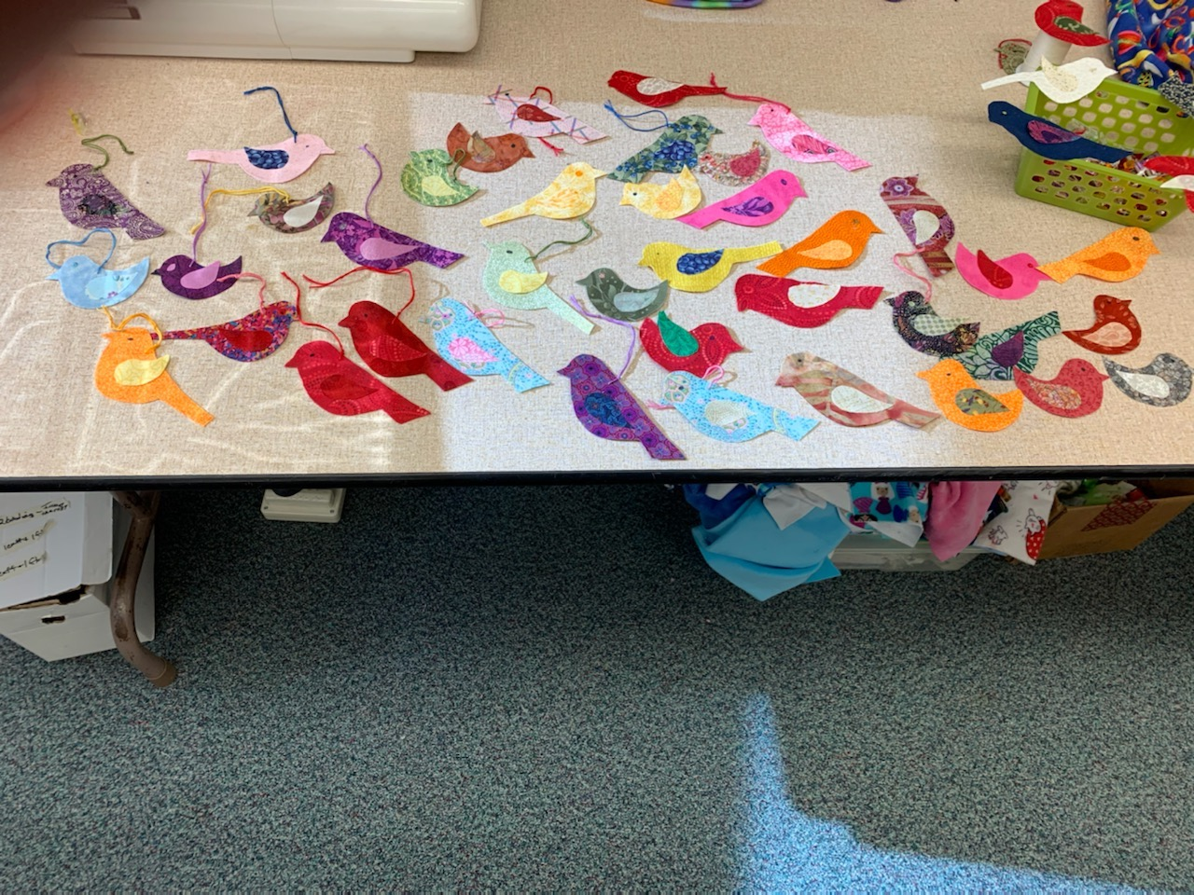

Our Homebound Church Family



**DECEMBER BIRTHDAYS**

1 Chad Dubois

14 Kristen Brandt

16 Jacob Bailey

17 Brenda Gowan

20 Laura Allard

22 Tom DeMarree

**DECEMBER LITURGISTS**

4 Donna Reuter

11 Tom Briggs

18 Mary Bryan

**DECEMBER ELDER**

Mark Lagoner

Anne Hotchkiss

1340 Parkwood Drive

Apt. 240

Macedon, NY 14502

**Birthday: September 21st**

Alice Morgan

2301 Lake Road

Ontario, NY 14519

**Birthday: March 27th**

Ruth Naylor

Maplewood Nursing Home

100 Daniel Drive

#120

Webster, NY 14580

**Birthday: September 29th**

Dave Scheffinger

1016 Railway Crossing

Webster, NY 14580

**Birthday: June 30th**

Jo SomDeCerff

4233 Scarlet Sage Court

Ellicott City, MD 21042

**Birthday: October 25th**

Lorrayne Walvoord

4281 Congdon Road

Williamson, NY 14589

**Birthday: October 21st**

Marilyn Bixby

Wayne County Nursing Home

1529 Nye Road

Lyons, NY 14489

**Birthday: March 7th**

Don DeMarree

900 Cherry Ridge Blvd.

The Glen – Apt. 118

Webster, NY 14580

**Birthday: April 17th**

Louise Hermenet

Victor Views

1440 Rt. 444

Victor, NY 14564

**Birthday: September 25th**

Bob & Carol Hopkins

4172 Washington Street

P.O. Box 192

Pultneyville, NY 14538

**Birthday: Bob – January 2**

**Birthday: Carol – September 5**

Jennie Hubright

Solstice Senior Living

55 Ayrault Road

Room 113

Fairport, NY 14450

**Birthday: October 19th**



[This Photo](https://aarafacademy.com/send-greetings-cards-via-email-php-mysql/) by Unknown Author is licensed under [CC BY-SA](https://creativecommons.org/licenses/by-sa/3.0/)

**Consistory Directory**

Office: 315-589-2703

**Pastor**

**Rev. Eric Titus**

**585-405-3379—Cell or 315-589-0033—Home**

**prcpastor@pultneyville.org or** [**titusyale90@aol.com**](mailto:lfiegl1@rochester.rr.com)

**Deacons**

**Chip Bailey**

315-587-5030

kcbnyusa@rochester.rr.com

**Craig DeNagel**

585-520-2787

craigcdenagel@gmail.com

**Chelsea Manahan**

315-576-6303

chelsea.manahan@gmail.com

**Donna Reuter**

315-576-0237

dreuter8766@yahoo.com

**Elders**

**Amy Burdett**

585-730-2563

[acburdett2006@icloud.com](mailto:acburdett2006@icloud.com)

**Alison DeMarree**

315-576-6339

[demarreeff@aol.com](mailto:lfiegl1@rochester.rr.com)

**Mark Lagoner**

585-764-1833

[mlagoner@rochester.rr.com](mailto:lfiegl1@rochester.rr.com)

**Carolyn Youngs**

315-879-7260

[c64youngs@yahoo.com](mailto:rmorgan004@rochester.rr.com)

**PROGRAM COMMITTEE MEMBERS**

Christian Education

Amy Burdett

Alison DeMarree

Linda Dubois

John Manahan

Kate Orbaker

Paula Shultes

Building and Property

Tom DeMarree

Craig DeNagel

Mark Fiegl

Ralph Morgan

Fred Walvoord

Worship

Lois Fiegl

Jim Fox

Karen Fox

Jane Morgan

John Setchell

Paula Shultes

Matthew Yost

Tonja Yost



**PINES OF PEACE**

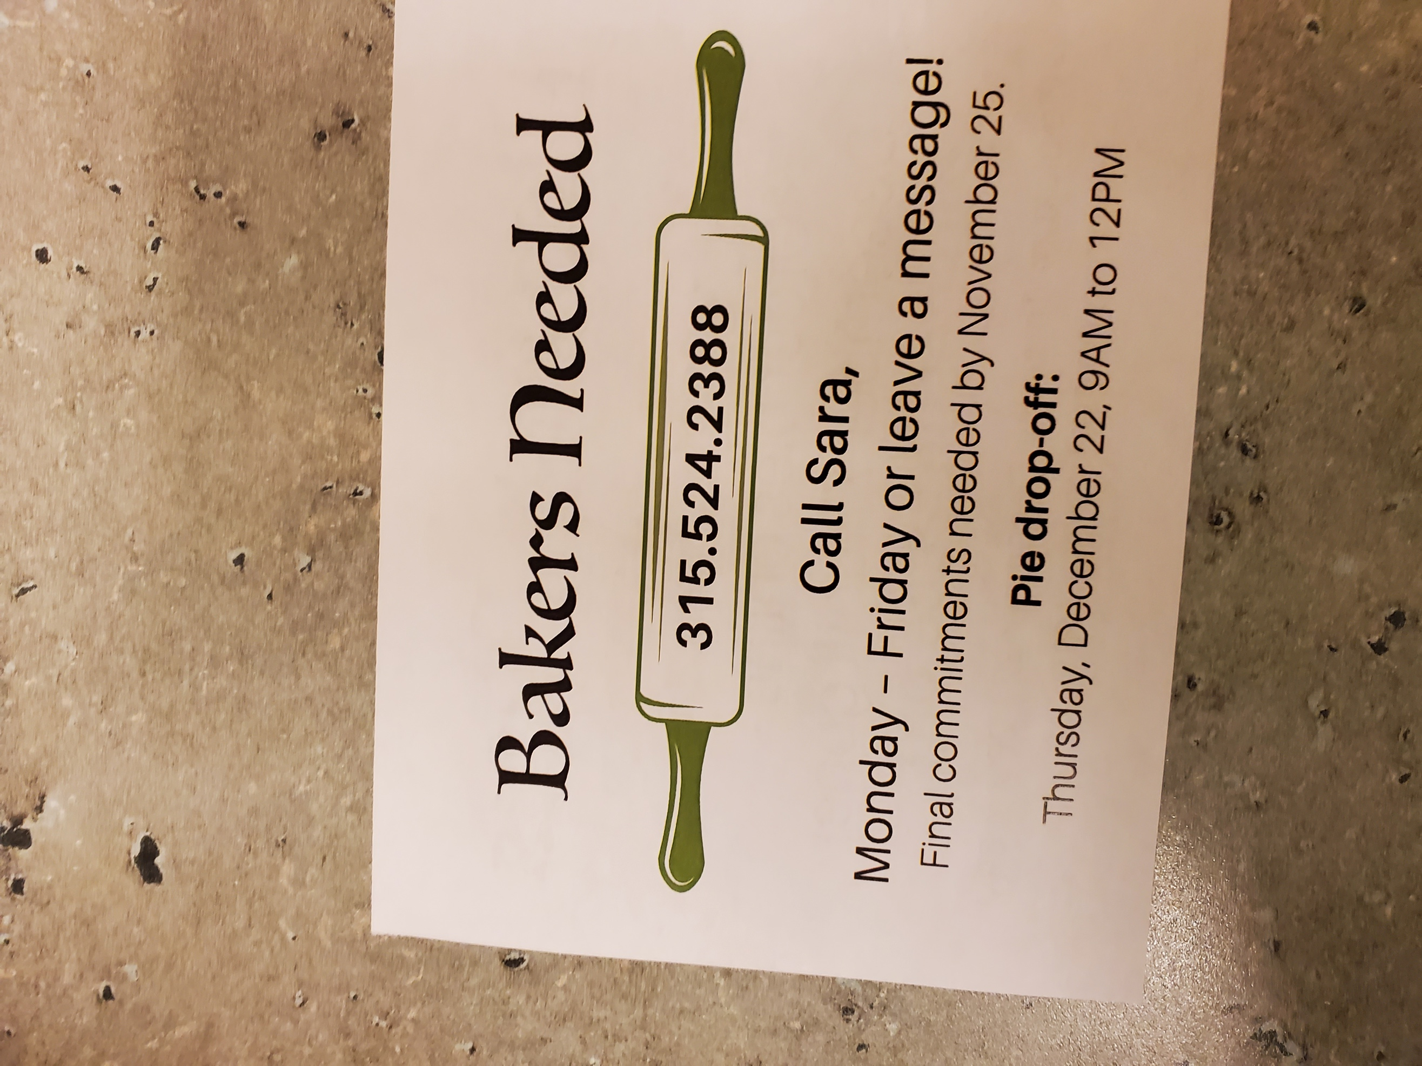

Missions

Amy Burdett

Julie Fuller

Paul Heilman

Rosemary Heilman

Tom Moenter

Nancy Titus

Parish Life

Kathy Baxter

Diana Lagoner

Chelsea Manahan

Karen Manahan

Ralph Morgan

Donna Reuter

Jim Williams

Karen Williams

Carolyn Youngs



DEC2022

| **S** | **M** | **T** | **W** | **T** | **F** | **S** |
| --- | --- | --- | --- | --- | --- | --- |
|  |  |  |  | 1  9:30 Bible Study  12:00 Caring Hands  1:00 Missions | 2 | 3 |
|  |  |  |  |  |  |  |
| 4  8:40 Choir  10:00 Worship  11:15 Cong. Meeting | 5 | 6 | 7 | 8  9:30 Bible Study | 9 | 10  9:00 Caring Hands  2:00 Caroling Event |
| 11  8:40 Choir  10:00 Worship  7:00 Vespers | 12 | 13 | 14 | 15  9:30 Bible Study  12:00 Caring Hands | 16 | 17 |
|  |  |  |  |  |  |  |
| 18  8:40 Choir  10:00 Worship  5:00 Connections Deadline | 19 | 20 | 21  7:00 Consistory | 22 | 23 | 24  9:00 p.m. Worship |
|  |  |  |  |  |  |  |
| 25  10:00 Worship | 26 | 27 | 28 | 29  12:00 Caring Hands | 30 | 31 |